Challenge -9

**Objective:** Create an AI that forecasts power outages 24hrs early using weather + grid data

**Data Inputs:**

Weather data - [Weather in Karnataka, India](https://www.timeanddate.com/weather/india/karnataka) and [IMD | District-Wise-Warnings](https://mausam.imd.gov.in/imd_latest/contents/districtwise-warning_mc.php?id=13)

**Expected Output:**

* Using the Weather Data Predict the power outages for Karnataka State using the weather data provided.
* In the case of Warnings, Heavy rain, Lightning and Thunderstorms pinpoint the location in the map.

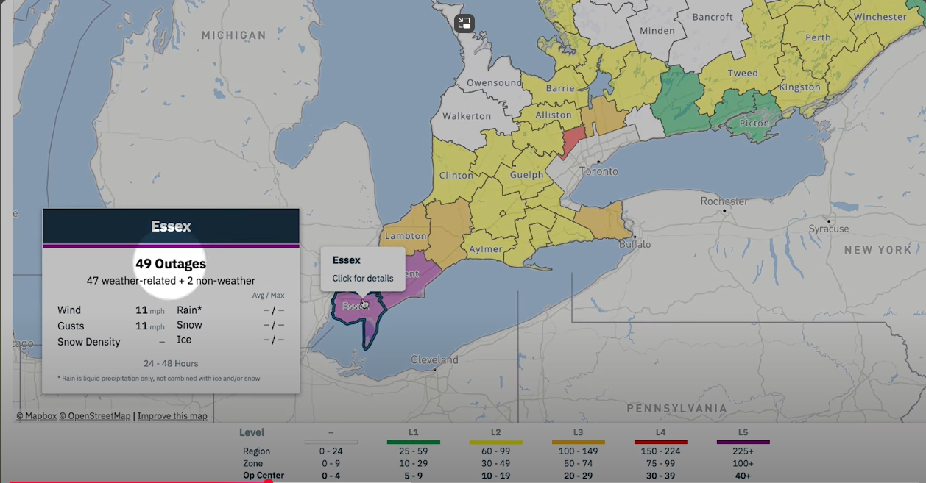

IBM Outage prediction: [Output](https://youtu.be/Up5wuFhPOPE?si=XhLbud4wrePdIYIf)